Math 240 Exam III Fall 2017 _____________

1. (6 pts) Find the value of b such that  =10

2. (8 pts) Given that 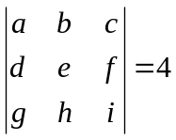find the determinant of each of the following matrices.

a) 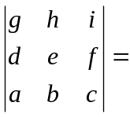 b) 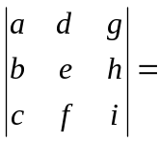 c) 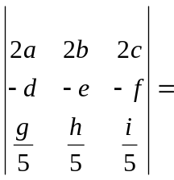 d) 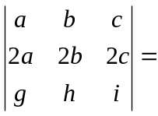

3. (10 pts) A is a 9 x 12 matrix with rank 7. Give the dimension of these subspaces.

a) 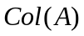 b) 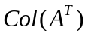 c) 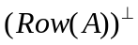 d) Null(A^{T}) e)Null(A)

4. (6 pts) If A is an invertible matrix with eigenvalueand corresponding eigenvector x prove that 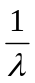 is an eigenvalue for A⁻¹.

5. (10 pts) Consider the matrix A =  with eigenvalues 1, 2, and 3.

a) (6 pts) Find a basis for the eigenspace corresponding to =1.

b) (4 pts) Is the matrix A diagonalizable or not? Give a reason for your answer.

6. (12 pts) Let w₁ = 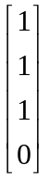 and w₂ = 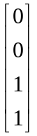 and let W = span (w_{1,} w₂).
a) Find a vector v that is in W and is orthogonal to w₁.

b) Find a basis for the orthogonal complement 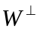

7. (8 pts) Show that the set of vectors B = 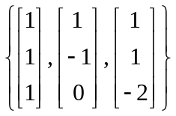 form an orthogonal basis for R³ and find the coordinate vector of 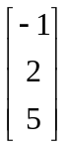with respect to that basis.

8. (10 pts) Let v = 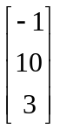 and W = span 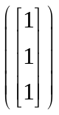. Find the orthogonal decomposition of v with respect to W. v = w + w

9. (10 pts) Recall that P₂ is the set of all polynomials with real coefficients and degree at most 2. Let W = {a + bx + cx²: a+b+c = 0}. Prove that W is a subspace of P ₂.

10. (8pts) The set of polynomials 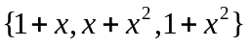is a basis for P ₂. Find the coordinate vector for 1+2x+3x² with respect to this basis.

11. (6 pts) Suppose A and B are n x n orthogonal matrices. Prove that the product AB is orthogonal.

12. (6 pts) What is the dimension for each of the following vector spaces?

a) Pn b) M_{jk} c) The set of upper triangular 3 x 3 matrices

